**STAT303 Project Report**

1. **a)**

**Dataset11:**

Code:

Summary Statistics

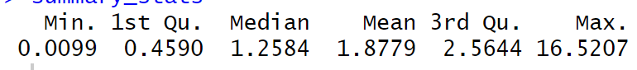

Histogram

From the histogram, my first guess is it might be from Gamma distribution with shape parameter α, and scale parameter β.

**Skewness:**  , **Kurtosis:** for Gamma distribution.

Code:

Output:

Empirical Skewness: 2.452519

Empirical Kurtosis: 15.44674

Theoretical Skewness:1.987

Theoretical Kurtosis: 5.915

Use Q-Q plot to show how well the data fits the Gamma distribution:

It aligns well. Now use fitdistr function to find the parameters.

Output:

Shape (α): 0.9382593

Rate (β): 0.4996408

Since it is found as Gamma(1,0.5), it can be considered as Exp(0.5).

Parameter Estimation

*f(x; α,β) = = =*

* MLE (Maximum Likelihood Estimation):

Code:

Output:



* MME (Method of Moments Estimation)

When we plug the values, the followings are obtained:

=0.5

For a random sample:

Code:

Output:

2) a)

Relative Efficiency =

For MME, its variance is

Var(MME): 5.279146, Var(MLE):5.279146

**2b)**

*f(x;*  *) = = =2*

Since exponential distribution is a member of exponential family distributions,

*f(x; θ) =*

From this form, we can say that = is complete sufficient statistic. However, it is not unbiased. To make it unbiased, it is divided by n, resulted as

Since it is unbiased and a function of CSS, it is UMVUE for by Lehmann- Scheffe Theorem.

**Distribution of MLE:**

* x ~Exp(2)
* ~Gamma(n,2)
* . Hence, ~ Gamma(n,2n)

2c)

Code:

Output:



3.

a) UMVUE

Code:

Output:

Probability of observing a value less than 8 is approximately 97%, and obtaining a value greater than 8 is 3%.

b) MME

Code:

Output:

Probability of observing a value less than 8 is approximately 97%, and obtaining a value greater than 8 is 3%.

Dataset21:

Summary Statistics



Since the histogram is bell-shaped, I assume that the dataset is normally distributed with location parameter µ, and scale parameter σ.

For Normal dist: **Skewness:** 0 , **Kurtosis:** 3

Match those theorotical values with emprical ones.

Output:

Skewness(-0.0784) states that the distribution is almost symmetric since the skewness is very close to 0.

Kurtosis(6.0363) is close to 3, aligns with Normal distribution.

Use fitdistrplus to see Q-Q plot and estimate parameters.

Hence, our final decision is the dataset comes from a Normal distribution.

So, *f(x; µ,) = = =*

MLE estimate:

Code:

Output:

, .

From the likelihood, we can conclude that , is the MLE for µ.

So, The Maximum Likelihood Estimator (MLE) for  is the average of the squared deviations from the mean.

* MME (Method of Moments Estimation)

,

Plug the values:

Having drawn 100 sample from the dataset, the calculated estimates are as follows:

Code:

Output:

**2.a)**

For µ,

For µ,

|  |  |
| --- | --- |
| Var(MME) | 0.031686 |
| Var(MLE) | 0.031686 |

The variance of both estimators are the same.

For ,

|  |  |
| --- | --- |
| Var(MME) | 0.2028288 |
| Var(MLE) | 0.2028288 |

The variance of both estimators are the same.

**2b)**

Since Normal distribution is a member of exponential family distributions,

,

For µ, is CSS. is UMVUE, because it is unbiased form of CSS. It is calculated as 0.23

For , is CSS. To make it unbiased, it should be divided by (n-1)

it is UMVUE. It is calculated as 3.8011694.

**Distribution of MLE:**

For µ:

* x ~Normal(0, 4)
* ~Normal (0,4n)
* ~Normal(0, 4/n)

For :

* ~
* ~

**2c)**

For µ:

Code:

Output:



We are 95% confident that the true value of the parameter falls into the constructed confidence interval for the Maximum Likelihood Estimator (MLE).

For

Code:

Output:



We are 95% confident that the true value of the parameter falls into the constructed confidence interval for the Maximum Likelihood Estimator (MLE).

For mu, MME is UMVUE. Therefore, the result will be the same for part a and b.

**3)**

Code:

Output:

P(X > a): 0.3158814 , P(X < a): 0.6841186

Probability of observing a value less than 1 is approximately 68%, and obtaining a value greater than 0 is 32%.

**Dataset 31:**

The distribution is known: Gamma(2,1).

**1b)**

* MLE (Maxiumum Likelihood Estimation)

Code:

Output:

* MME (Method of Moments)

Code:

Output:

For a random sample of 100 size:

* MME (Method of Moments)

Code:

Output:

MLE (Maxiumum Likelihood Estimation)

Code:

Output:

**2a)**

For α

|  |  |
| --- | --- |
| Var(MME) | 0.02 |
| Var(MLE) | 0.02 |

Their variance is the same.

For β

|  |  |
| --- | --- |
| Var(MME) | 0.01 |
| Var(MLE) | 0.005 |

MLE is 2 times more efficient than MME for β.

**2b)**

Gamma distribution is member of exponential family, so is CSS. However, it is biased.

For α, we know that data is distributed with Gamma (2,1). To make it unbiased it is divided by n and β. The UMVUE becomes

For β, we know that data is distributed with Gamma (2,1). To make it unbiased it is divided by n and α. The UMVUE becomes

Code:

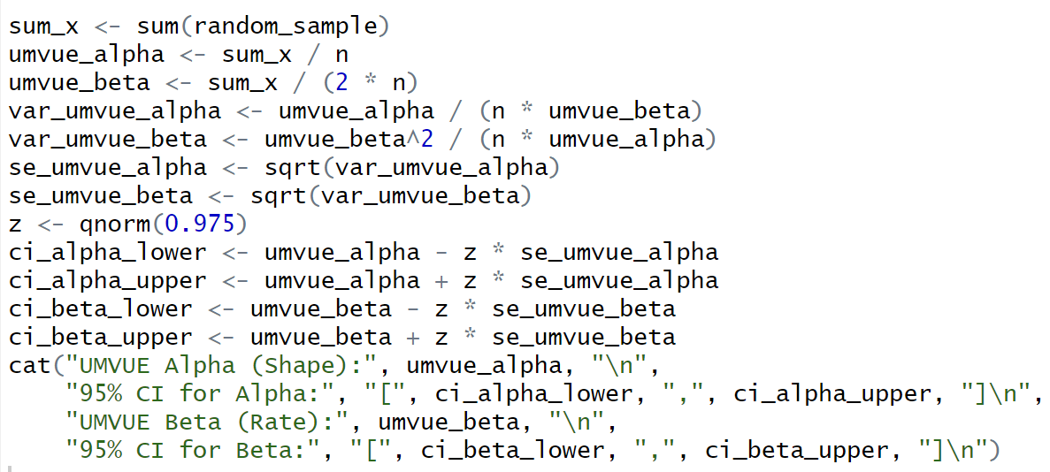

Output:

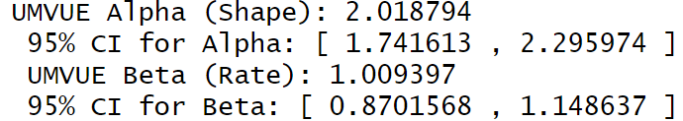

We are 95% confident that true and estimated values of parameters fall into the constructed interval for the MLE.

3)

a,b)

Code:

Output:

UMVU Estimator: P(X > a): 0.09090061 , P(X < a): 0.9090994

The probabilities from the UMVU estimator suggest that there is approximately a 9.1% chance of observing a value greater than 4 and a 90.9% chance of observing a value less than 4.

MME Estimator: P(X > a): 0.09395588 , P(X < a): 0.9060441

The probabilities from the MME estimator suggest that there is approximately a 9% chance of observing a value greater than 4 and a 91% chance of observing a value less than 4.